Vocabulary: Biology Unit: Date:
Picture | Word | Definition
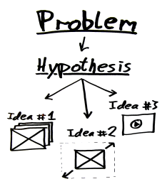 | Hypothesis | Educated guess.  --- If….then…..  ---Test hypothesis by performing a controlled experiment
 | Variable | Anything that can be changed in an experiment that can affect the outcome of an experiment
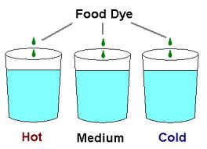 | Independent variable | The variable that is changed in an experiment in order for to test its effect on the outcome.  --The cause.  --If……  --Manipulated variable
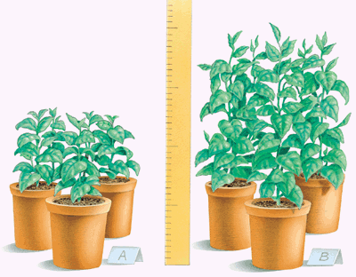 | Dependent variable | The variable (outcome) of an experiment that depends on the independent variable.  ---The effect  ---Then……  ---Responding variable
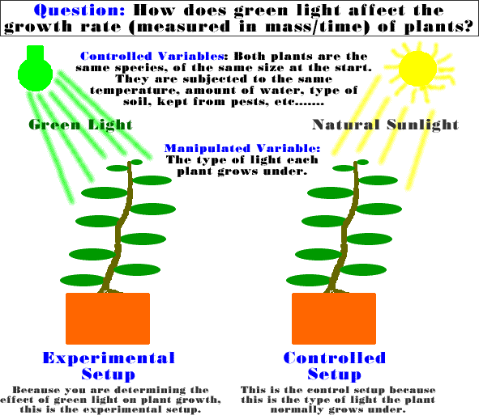 | Control | The test set up that has no changes.  --Used to compare the test set ups in an experiment.
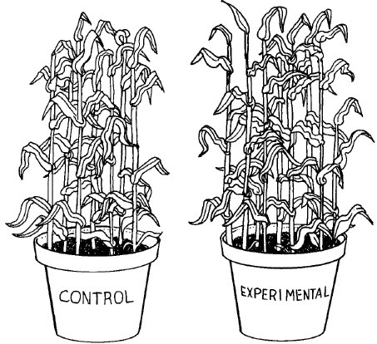 | Controlled experiment | An experiment that only tests one variable at a time.  ---Includes a control group and test groups

