BIOME WEBQUEST Name:
Part I: Flora and Fauna of major biomes
Explore the links at the following website and use the information to fill in the chart below
http://www.mbgnet.net/index.html

Biome | Diversity of life (high, average, low) | Common  Plants | Plant  Adaptations | Common  Animals | Animal  Adaptations
Tundra

Taiga

(Coniferous Forest)
Temperate
Deciduous
Forests

Grassland
Savannas
Deserts
Tropical Rain
Forests

Part II – Climates of Major Biomes
The climate of a biome is the result of the interaction of several abiotic factors. These
factors include temperature, precipitation, and radiant energy from the sun, evaporation, wind
and humidity. These abiotic factors serve to limit the diversity of plants and animals found
within an ecosystem. Large ecosystems or biomes can be described in terms of their abiotic factors The two most important of these limiting abiotic factors are temperature and precipitation. A climatogram is a graph with a double-Y axis that plots the average monthly
temperature & precipitation in a biome.
http://earthobservatory.nasa.gov/Experiments/Biome/index.php

Biome  Example Location | Temperature Range (include units) | Rain fall per year (include units) | Seasonal trends  (Describe average winter and summer in terms of temps, rainfall, amt. of sunlight) | Climatogram matching: write the letter of the climatogram below that would best fit each biome
Taiga (Coniferous forest)

Temperate (deciduous) forest

Desert

Grassland

Rainforest

Tundra

Examples of climatograms (or climate graphs): See if you can figure out which graph matches each biome in the table above.
A B C
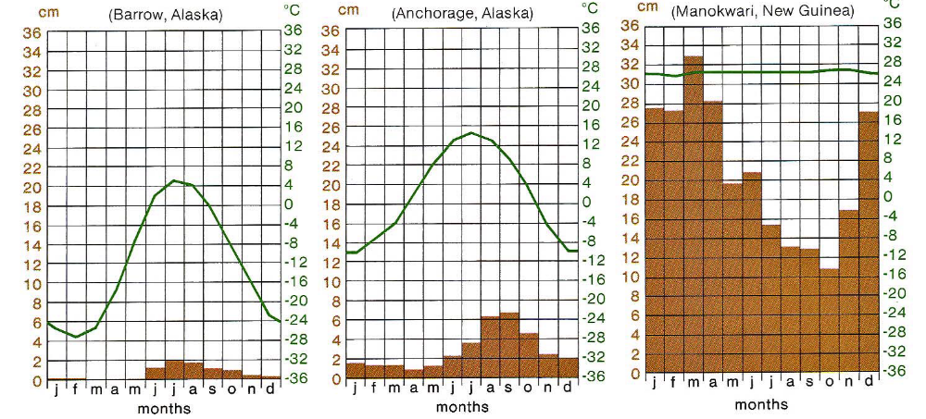

D E F

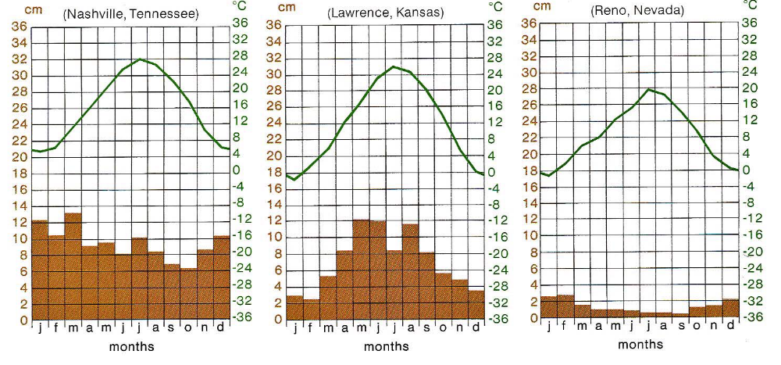

Part III: Marine Biomes - Read about the zones of marine biomes. Describe their location and list several organisms that live at each. http://www.ucmp.berkeley.edu/exhibits/biomes/marine.php#oceans
Zones of Marine Biomes | Description of Location | Common flora/fauna
Intertidal zone

Pelagic zone

Benthic zone

Abyssal zone

Coral reefs

Estuaries

Part IV: Freshwater Biomes - Describe the following freshwater habitats/zones and list several common flora and fauna of each. http://www.ucmp.berkeley.edu/exhibits/biomes/freshwater.php

Freshwater Biomes | Description | Common flora/fauna
Littoral zone (of pond or lake)

Limnetic zone (of pond or lake)

Profundal zone (of pond or lake)

Streams and rivers

Wetlands

