Vocabulary: Biology Unit: Date:
Picture | Word | Definition
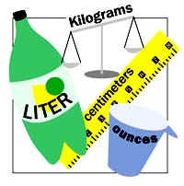 | Unit | A standard measurement used to compare an unknown object.  ---examples: meter, liter, gram, Celsius, dollar
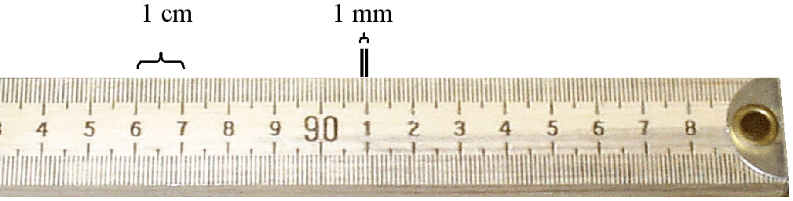 | Meter | The metric unit used for measuring length or distance.  --Use a meter stick to measure
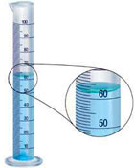 | Liter | The metric unit used for measuring the volume of a liquid.  --Use a graduated cylinder or beaker to measure.
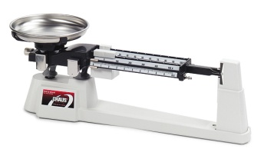 | Gram | The metric unit used to measure mass.  --Use a triple beam balance to measure.

