Vocabulary: Biology Unit: 6 DNA/mitosis/meiosis Date:
Picture | Word | Definition
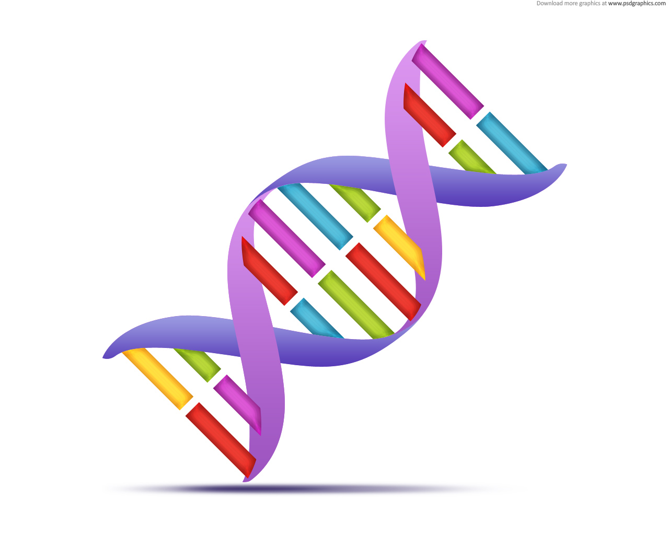 | DNA | -Deoxyribonucleic acid  -Contains genetic information to build organism (instructions build proteins)  -Found in nucleus of eukaryotic cells, in cytoplasm of prokaryotic cells.  -Double helix made of nucleotides.
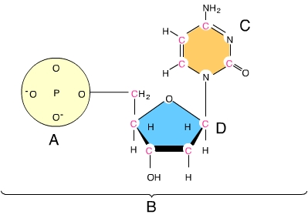 | Nucleotide | -The monomer of nucleic acids  -DNA: deoxyribose sugar, phosphate group, and nitrogenous base  ----bases: A,T,C, and G
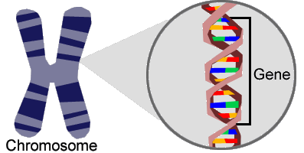 | Gene | -A section of DNA that contains the instructions for building a particular protein for the expression of a particular trait.
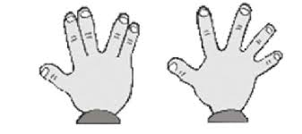 | Trait | -The physical expression of a gene.  --examples: eye color, hair color, ability to whistle or curl tongue.
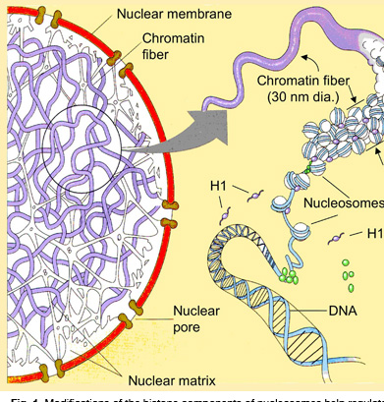 | Chromatin | -DNA that is uncoiled  -In the nucleus, during interphase.  -Is not visible, except as darker mass in cell.
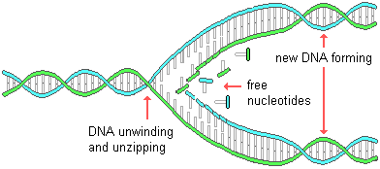 | Replication | -The process of making an exact copy of DNA in order to provide a copy for daughter cells.  -Occurs during the S phase of the cell cycle.
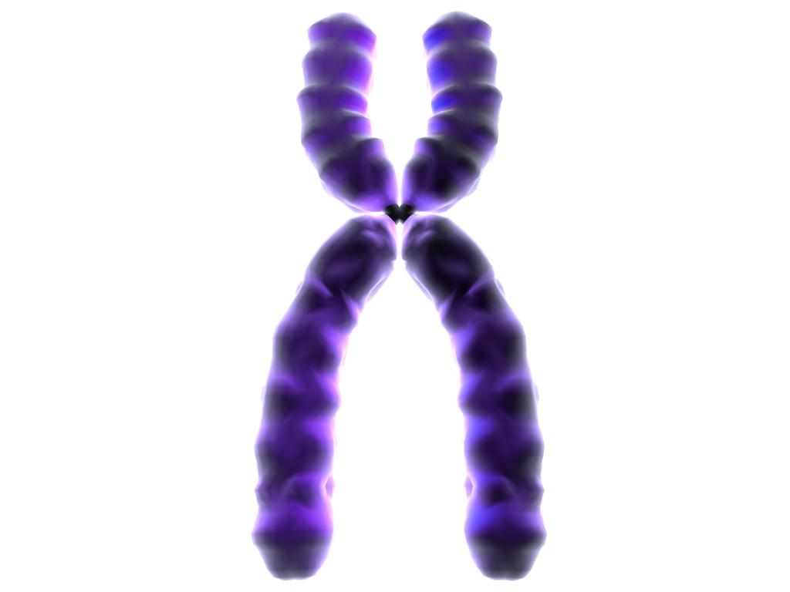 | Chromosome | -DNA that has become condensed (coiled up tightly)  -Only visible during cell division.  -Can be replicated (X) or unreplicated (/).
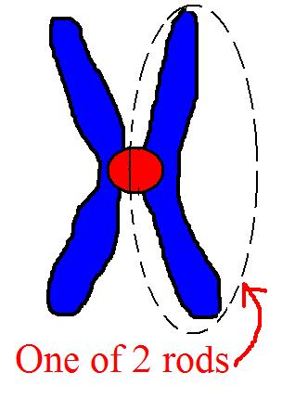 | Chromatid | -one of the “arms” of a replicated chromosome.  -“sister” chromatids are held together by a centromere until separated during cell division.
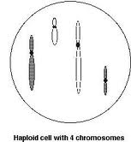 | Haploid | -One set of chromosomes  -“half” of the instructions necessary to build an organism.  -Number of chromosomes found in a gamete.  - haploid = n

Picture | Word | Definition
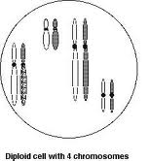 | Diploid | -two sets of chromosomes.  -the “full” set of instructions needed to build an organism.  -Number of chromosomes found in an organism after fertilization.  -Diploid = 2n
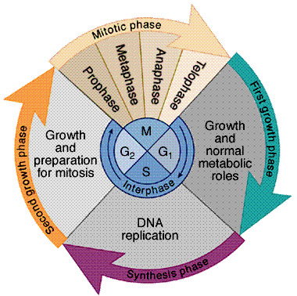 | Cell Cycle | -The stages that a cell goes though during cell division.  -Consists of the Interphase (G1, S, G2) and the M (mitosis and cytokinesis) phases.
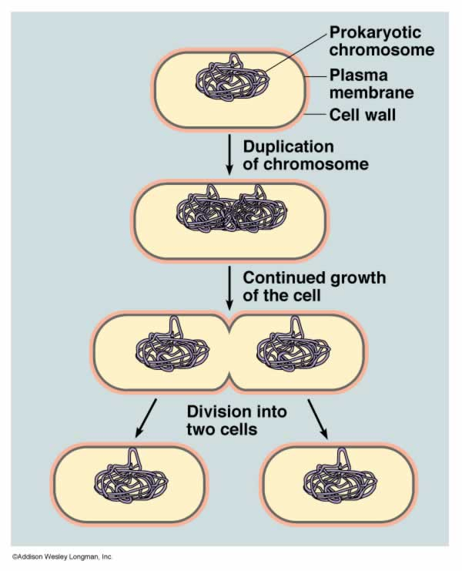 | Asexual Reproduction | -The production of offspring from one parent (one set of DNA).  -Offspring are genetically identical to parent.  -binary fission, mitosis, budding, cuttings.
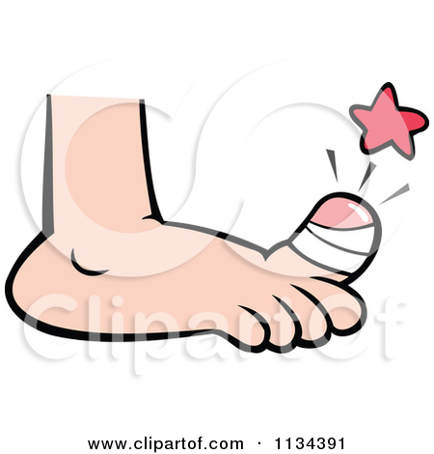 | Mitosis | -The division of a cell’s nucleus.  -Prophase, metaphase, anaphase, and telophase.  --for growth, tissue repair, cell replacement  --asexual reproduction: 1 cell produces 2 identical daughter cells
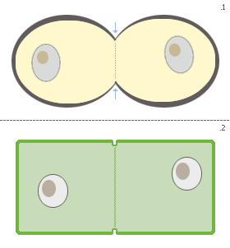 | Cytokinesis | -The division of a cell’s cytoplasm to create 2 separate cells.  -Often occurs during telophase (of mitosis).
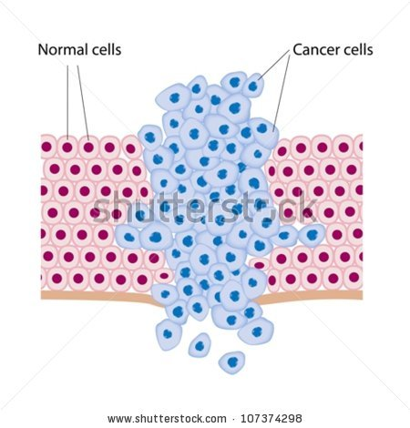 | Cancer | -The uncontrolled division of cells.  -Occurs when cells continue to divide unchecked without external or internal controls.  -Tumors are produced.
 | Meiosis | -The process of producing gametes (sex cells).  -1 diploid cell produced 4 haploid daughter cells that are genetically different from the parent cell.
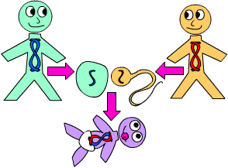 | Sexual reproduction | -The production of genetically unique offspring by 2 parents (2 sets of DNA).  -gametes produced by meiosis are fertilized to produce a zygote (first cell of organism).
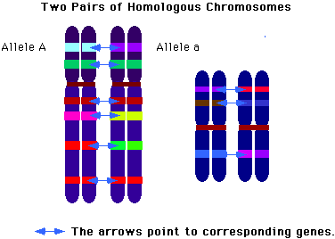 | Homologous chromosome | -A pair of chromosomes that contain the genes for the same traits.  -One of the chromosomes comes from one parent and the other chromosome comes from the other parent.  -These chromosomes pair up during meiosis I in order to reduce the number of chromosomes during division.

