Vocabulary: Biology Unit: 6: Protein synthesis Date: 1/9/2014
Picture | Word | Definition
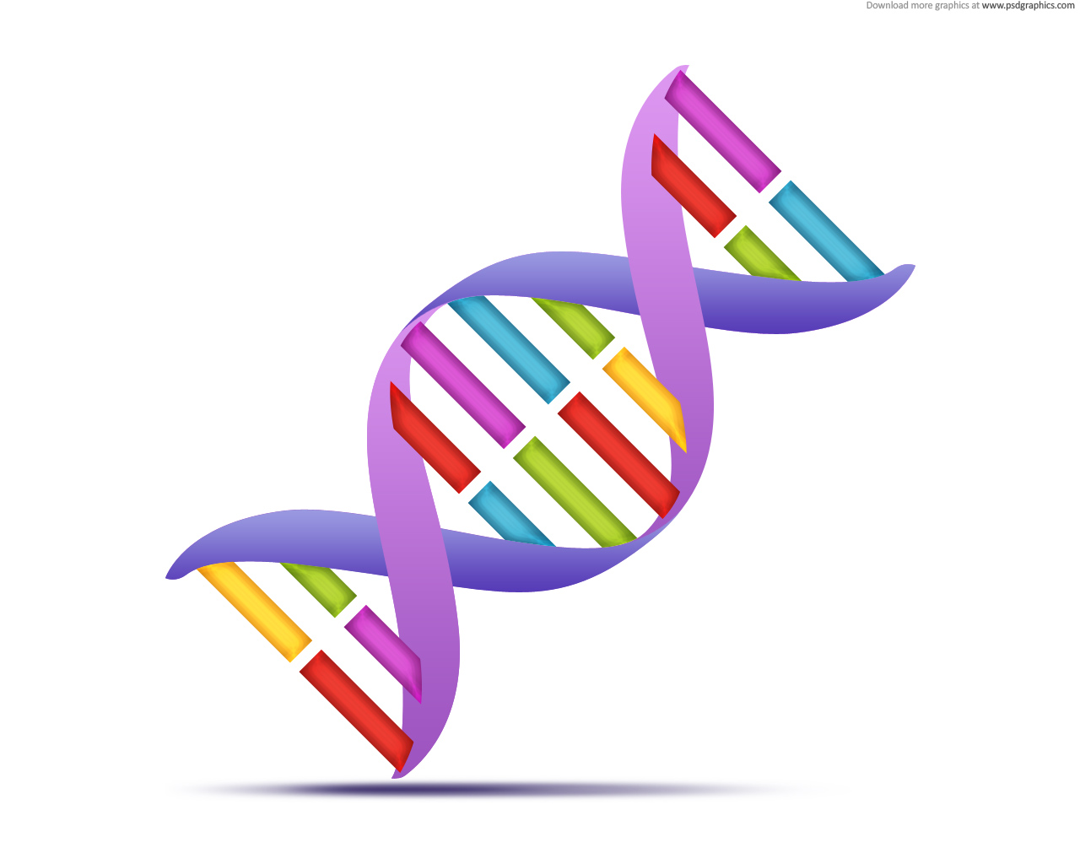 | DNA | -Deoxyribonucleic acid  -Contains genetic information to build organism (instructions build proteins)  -Found in nucleus of eukaryotic cells, in cytoplasm of prokaryotic cells.  -Double helix made of nucleotides.
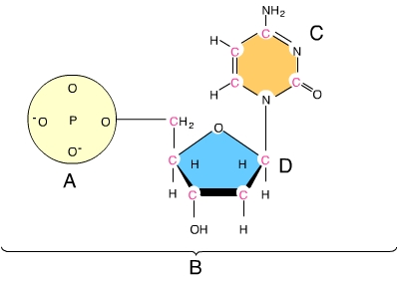 | Nucleotide | -The monomer of nucleic acids  -DNA: deoxyribose sugar, phosphate group, and nitrogenous base  ----bases: A,T,C, and G
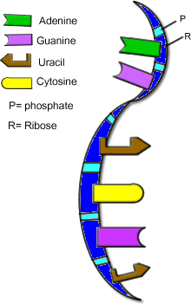 | RNA | -Ribonucleic acid  -A nucleic acid made of nucleotides that contain the sugar ribose, a phosphate group, and one of four nitrogenous bases (uracil, adenine, cytosine, and guanine).
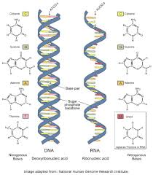 | mRNA | -Messenger RNA  -This molecule is made by a DNA template during transcription so that the instructions found in DNA can be carried out of the nucleus to the ribosomes in the cytoplasm so that proteins can be made.
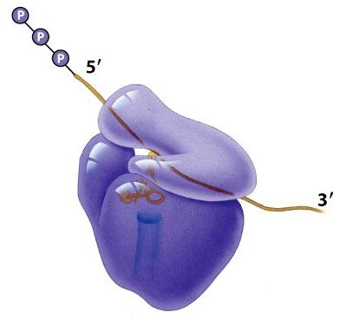 | rRNA | -Ribosomal RNA  -2 rRNA subunits are combined to make a ribosome that will scan mRNA to assemble a protein.
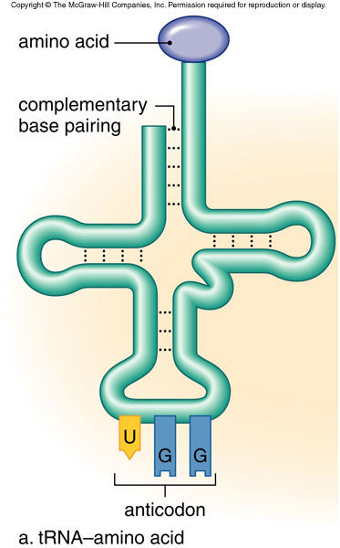 | tRNA | -Transfer RNA  -A clover shaped molecule that brings specific amino acids to the ribosome so that a protein can be assembled using the instructions found on the mRNA molecule.
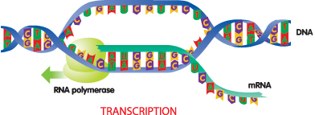 | Transcription | -The process of making (synthesizing) mRNA from DNA.  -Occurs in the nucleus.
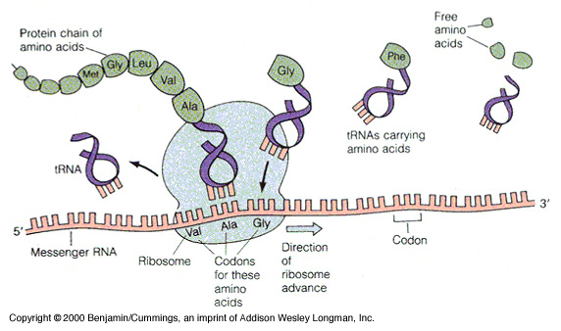 | Translation | -The process of making a protein from the coded message found on mRNA.  -Involves tRNA and ribosomes.  -Occurs in the cytoplasm.
 | Ribosome | -“Scans and reads” the mRNA codons so that it can build a protein.  -made by combining 2 smaller rRNA molecules inside the nucleolus.  -like a bar code scanner
Picture | Word | Definition
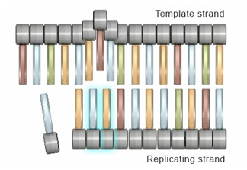 | Template | -A guide that is used to build or make something.  -RNA is made using the template provided by DNA to put the RNA nucleotides in the correct order.
 | Polypeptide | -A protein  -A chain of amino acids  -made at the ribosome during translation using the codons on mRNA.
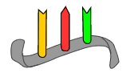 | Codon | -A “word” in the message found on mRNA that is made up of three bases (nucleotides)  -ex: AUG is the codon that codes for the amino acid methionine.
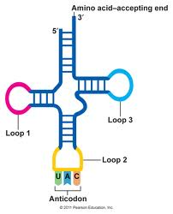 | Anticodon | -A series of three bases at the end of a tRNA molecule that is complementary (matches) with the codon found on mRNA.  -each anticodon is specific for one of the 20 different amino acids.
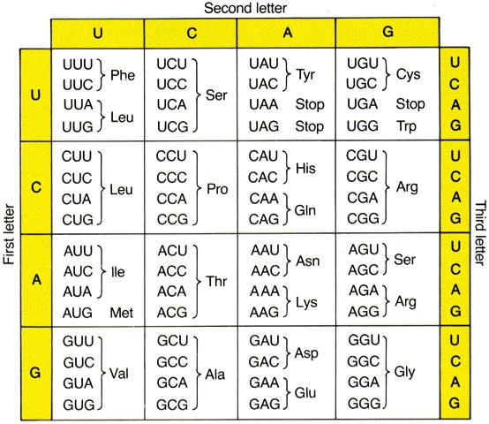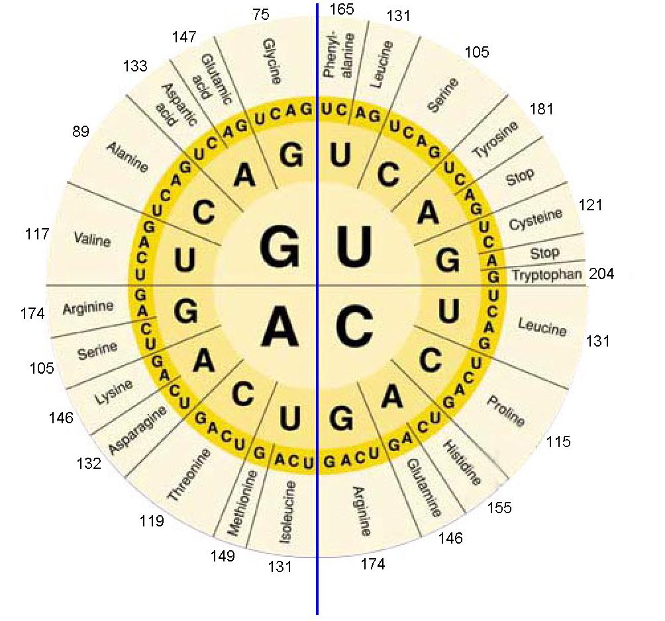 | Genetic code | -A chart that is used to “translate” the codons found on mRNA into which amino acid will be put into the newly formed protein.  -There are 64 different codons that code for 20 different amino acids so some amino acids are coded by several different codons.
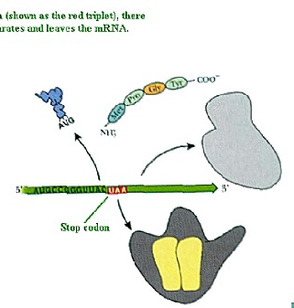 | Stop codon | -A codon found on mRNA that signals that a protein has been completed.  -It signals the ribosome and the protein to be released from the mRNA.  -UAA, UAG, UGA
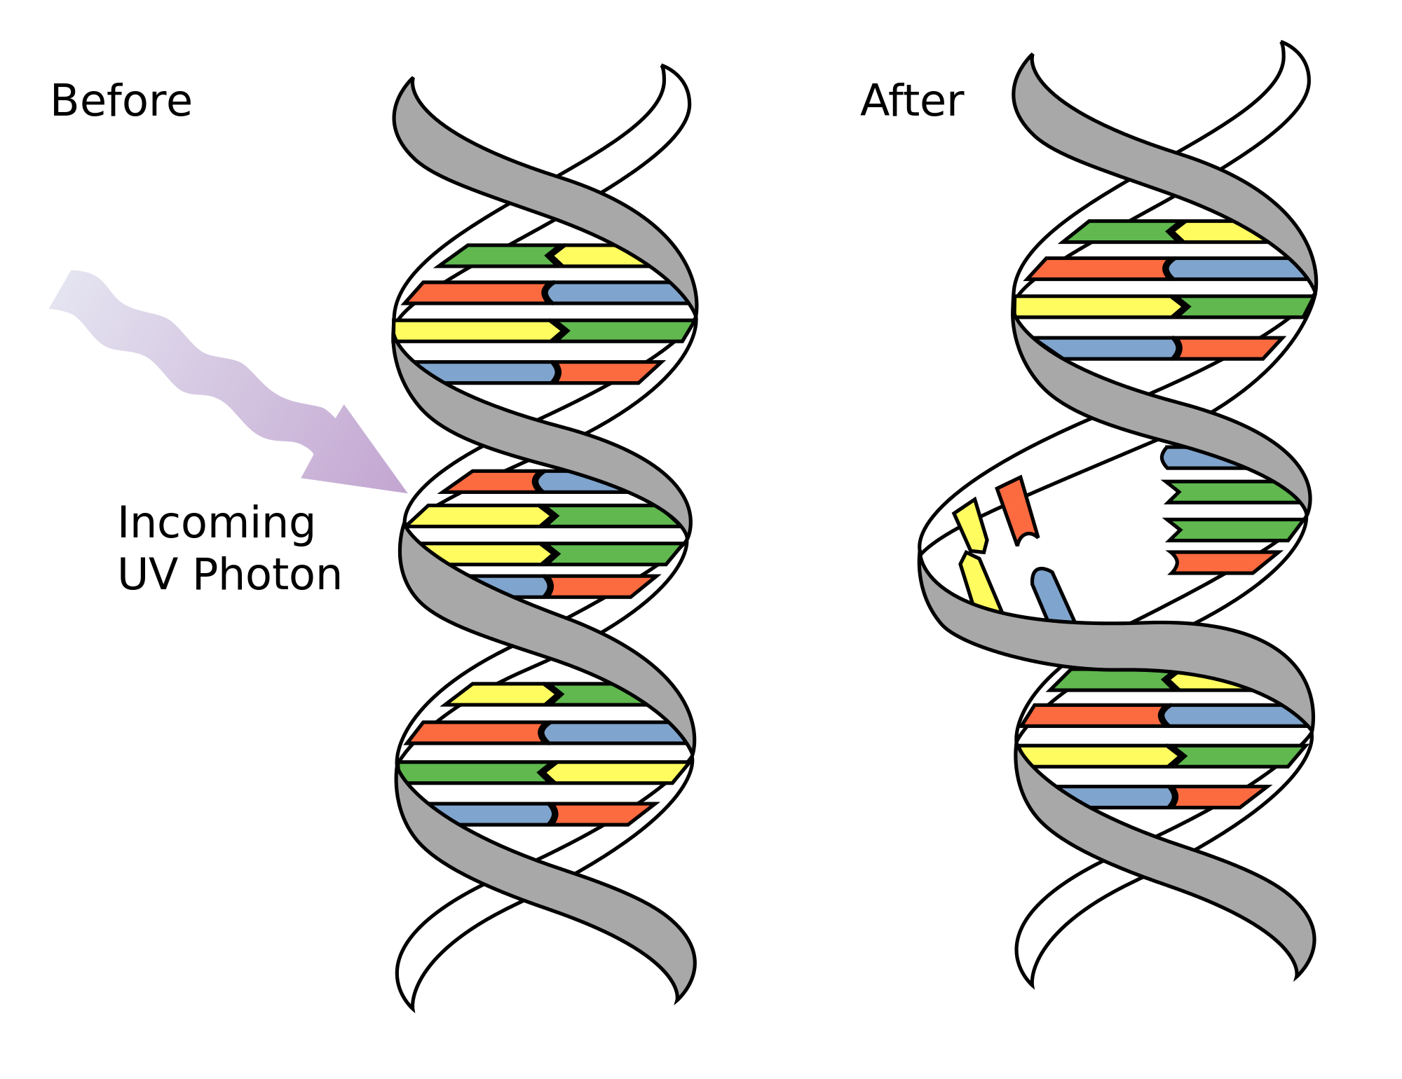 | Mutation | -A change in the DNA  -caused by mutagens (xrays, chemicals, etc.)  -Change in DNA may result in change in amino acids which may change proteins and traits  -point mutations: substitution of one base  -Frame shift mutation: inserting or deleting a base causes codon reading frame to shift.

