Vocabulary: Biology Unit: 8: Genetics Date:
Picture |  | Word |  | Definition
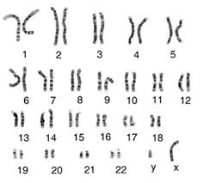 |  | Karyotype |  | A picture/photograph that shows homologous chromosomes, arranged by size, used to identify abnormalities in fetuses.  --Shows chromosomal mutations only
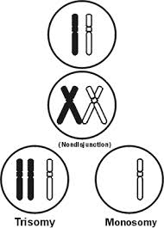 |  | Nondisjunction |  | The failure of homologous chromosomes to separate during meiosis.  --This results in gametes having multiple copies of a chromosome or missing chromosomes.  --trisomy 21 (extra 21), Turner’s syndrome (X), Klinefelter’s syndrome (XXY)
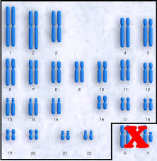 |  | Autosome |  | Chromosome pairs 1-22  --There are no differences between males and females.
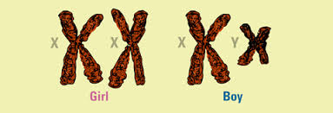 |  | Sex Chromosome |  | Chromosome pair # 23  --Determines gender: XX=female, XY = male  --X chromosome is larger and contains more genes than the Y chromosome. Reason why more males show sex-linked recessive traits.
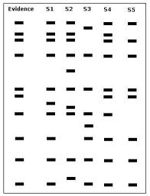 |  | DNA Fingerprinting |  | A technique that is used to compare unknown samples of DNA to known samples.  --Used in paternity testing and crime scenes
 |  | Gene |  | -A section of DNA that contains the instructions to build the proteins that will determine traits.
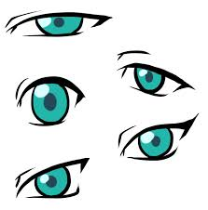 |  | Trait |  | - The physical expression of a gene that varies among individuals.  - Examples: hair color, hair texture, eye color, height
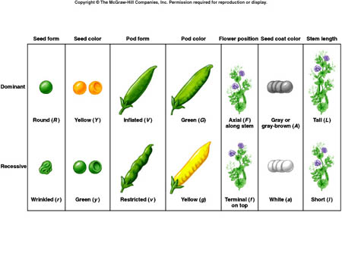 |  | Allele |  | - The different forms of a trait  - Example: tall or short, blue or brown, curly or straight
Picture |  | Word |  | Definition
 |  | Homozygous |  | - Contains two alleles in the same form.  - Pure breeding, true breeding  -Can be dominant or recessive.
 |  | Heterozygous |  | - Contains two alleles in different forms.  - Hybrid, carrier  -Contains one dominant and one recessive allele
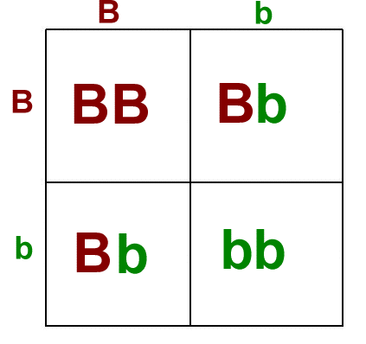 |  | Punnett square |  | - Used to predict the possible genetic outcomes of different test crosses.
A |  | Dominant |  | - The form of a trait that is shown if it is present.  -Example: Tall = Tt or TT
a |  | Recessive |  | -The form of a trait that is only shown if a dominant allele is absent. If dominant is present, recessive is hidden.  -Ex: Short = tt
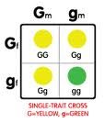 |  | Monohybrid cross | -A test cross involving only one gene (trait).  -Ex: Tt x tt  -Tall x short
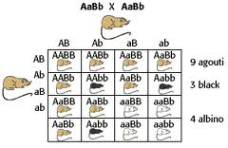 |  | Dihybrid cross | -A test cross involving two genes (traits)  -Ex: TtYy x ttYY  -Tall and yellow x Short and yellow
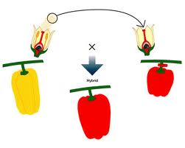 |  | Hybrid | -Heterozygous, contains one form of each allele.  -Aa
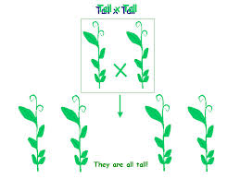 |  | Purebred | -Homozygous, true breeding  -Contains same form of allele  -AA or aa
 |  | Carrier | - Heterozygous individual  -The trait is not exhibited in an individual but the individual can pass the recessive allele to its offspring.
Picture |  | Word | Definition
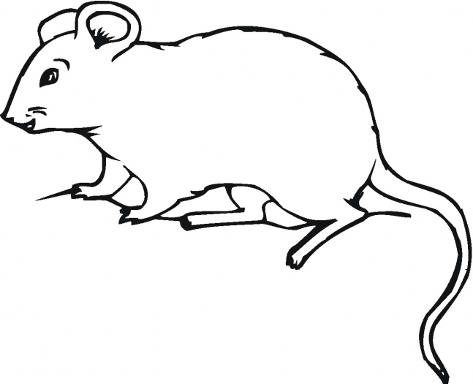 |  | Phenotype | -Physical appearance  -Tall or short, blue eyes or brown eyes, green or yellow
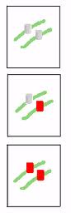 |  | Genotype | -The genetic makeup of a trait.  -TT, Tt, tt
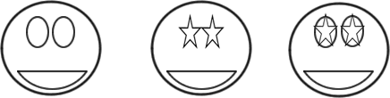 |  | Codominance | -When there is more than one allele that is dominant, the dominant alleles share dominance.  -Ex: RR = red, WW=white, RW= red and white
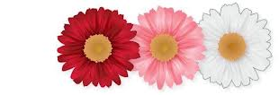 | Incomplete dominance |  | -When there is more than one allele that is dominant, the dominant alleles mix or blend when in the heterozygous form is present.  -Ex: RR = red, WW= white, RW = pink
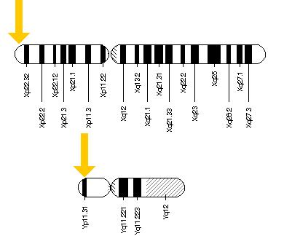 | Sex-Linked trait |  | -Any gene that is found on the sex chromosomes.  -Determine gender XX=femaile, XY = male  -more common in males.
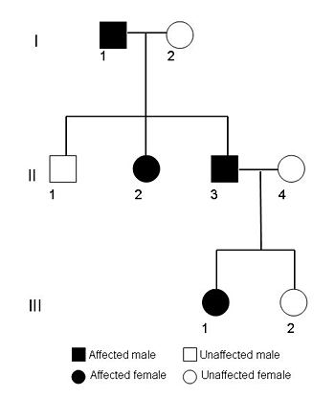 | Pedigree |  | A chart used to represent the genetic inheritance of a particular trait.  --Like a family tree but for genes  --Can be used to show autosomal dominant traits, autosomal recessive traits and sex-linked traits.

