Name_____________________________________ Date___________ Period_____________
Body System Interactions
Purpose: To investigate various human body systems and explain how they interact with each other to maintain homeostasis
Task: Construct a full body diagram of two of the following body systems and explain how they interact with each other
System | Organ | Function
Respiratory | Lungs, nasal passages, bronchi, pharynx, trachea, diaphragm, bronchial tubes | Intake of oxygen and removal of carbon dioxide from the body
Nervous | Spinal cord, brain, nerves, skin, eyes, ears, tongue, nose | Controls body activities and reaction to stimuli
Digestive | Stomach liver, teeth, tongue, pancreas, intestine, esophagus | Break down food and absorption used for energy
Excretory | Kidneys, bladder ureters, skin | Controls water and salt balance
Endocrine | Pituitary gland, adrenal gland, t thyroid gland, gonads | Production of hormones and body regulations
Skeletal and muscular | Bones, muscles | Protection and movement
Circulatory | Blood vessels, heart, lymph | Transport of nutrients, metabolic waste, water, salts, and disease fighting cells
Integumentary | skin | Protection from injury and bacteria, maintenance of tissue moisture, holds receptors for stimuli response, body heat regulation
Body systems _______________________________ and _______________________________
Construct a rough outline of a human form on a piece of poster paper. Draw in the major organs and parts of the two systems you have been given. Label everything!!
Be sure to include the following information on your poster
- List all the major organs in each of your systems.
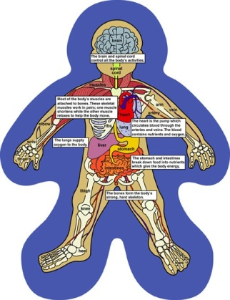
- Write a working definition of homeostasis.
- In paragraph form, briefly describe the function of each of your body systems.
- In a brief paragraph explain in detail how the two systems interact to maintain homeostasis within the body. (Example: “When Sally runs a marathon in the Texas heat, her skeletal and respiratory system work together by ………”) Include in the paragraph what would happen if something went wrong and the body systems no longer interacted together properly.

Be prepared to present you project and explain your systems interaction to the class

