Ionic Bonding Notes
Part one: Intro to Ionic Bonds
http://www.youtube.com/watch?v=Qf07-8Jhhpc

Chemical Bonding

Covalent Bonding Ionic Bonding Metallic Bonding

Chemical bonds are like glue that holds atoms together.

Ionic bonds connect ______________ and ______________.
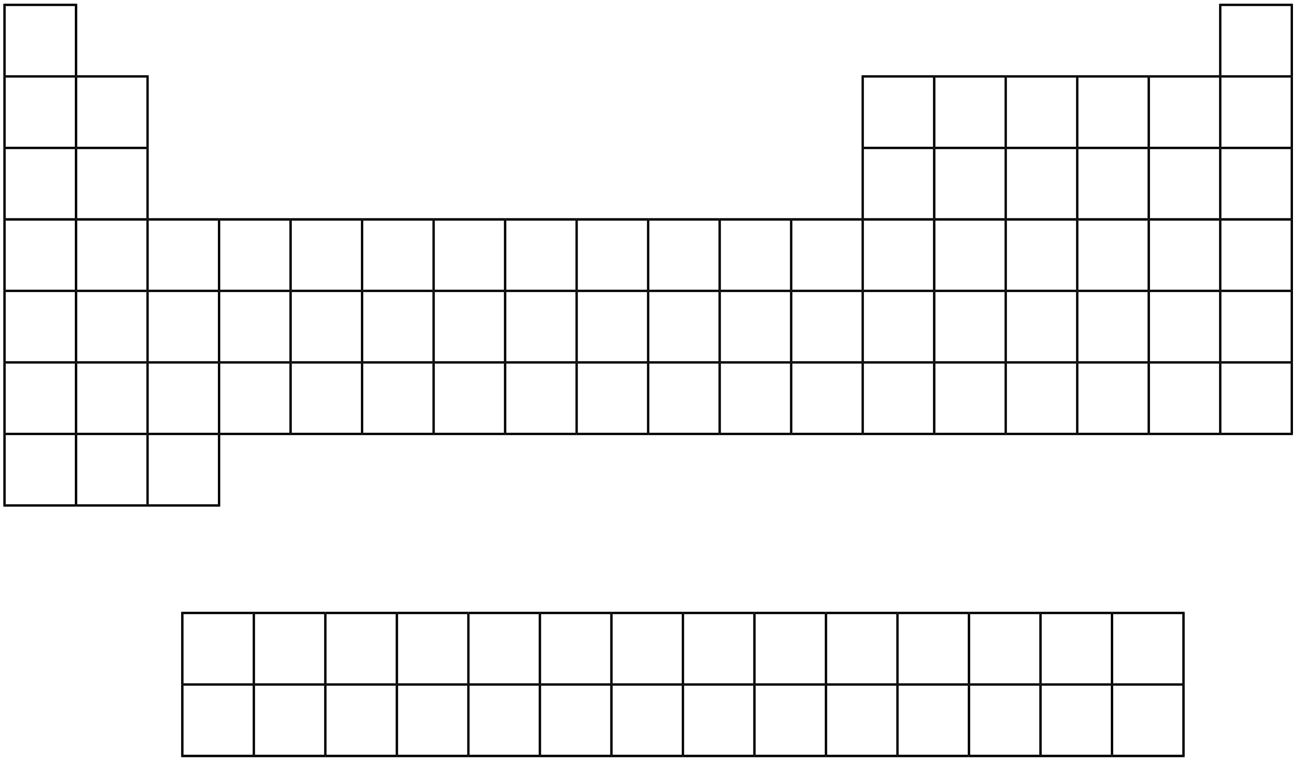

Example: NaCl is sodium chloride (aka: ____________)
The reason why these two atoms are connected is because they are electrically charged.
Na will end up with a ________ charge.
Cl will end up with a ________ charge.

Steps:
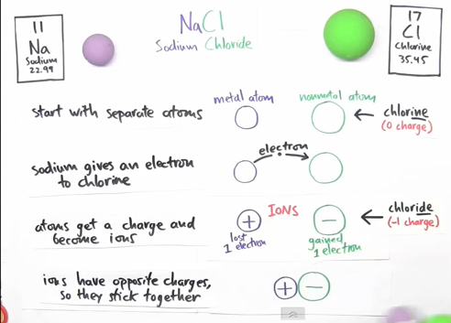

Part Tw0: why do Ionic bonds form?
http://www.youtube.com/watch?v=5EwmedLuRmw

11
Na
Sodium
22.99
17
Cl
Chlorine
35.45
NaCl
Sodium Chloride

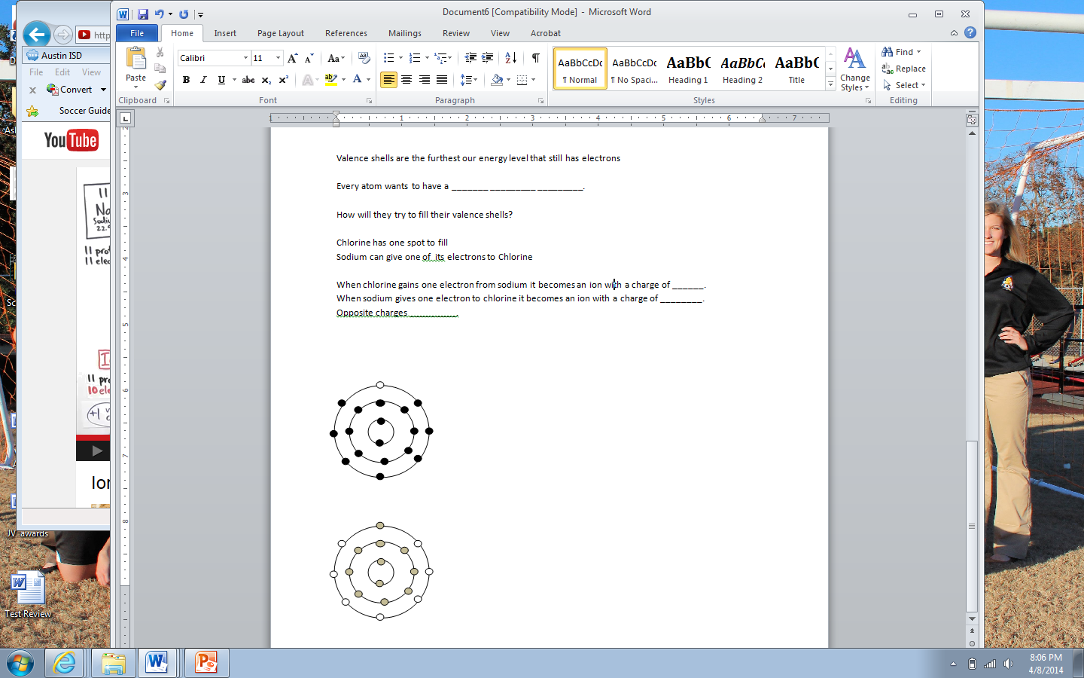
11p
17p
_____ Protons _____Protons
_____ Electrons _____ Electrons

__________________ Shells are the furthest out energy level that still has electrons.

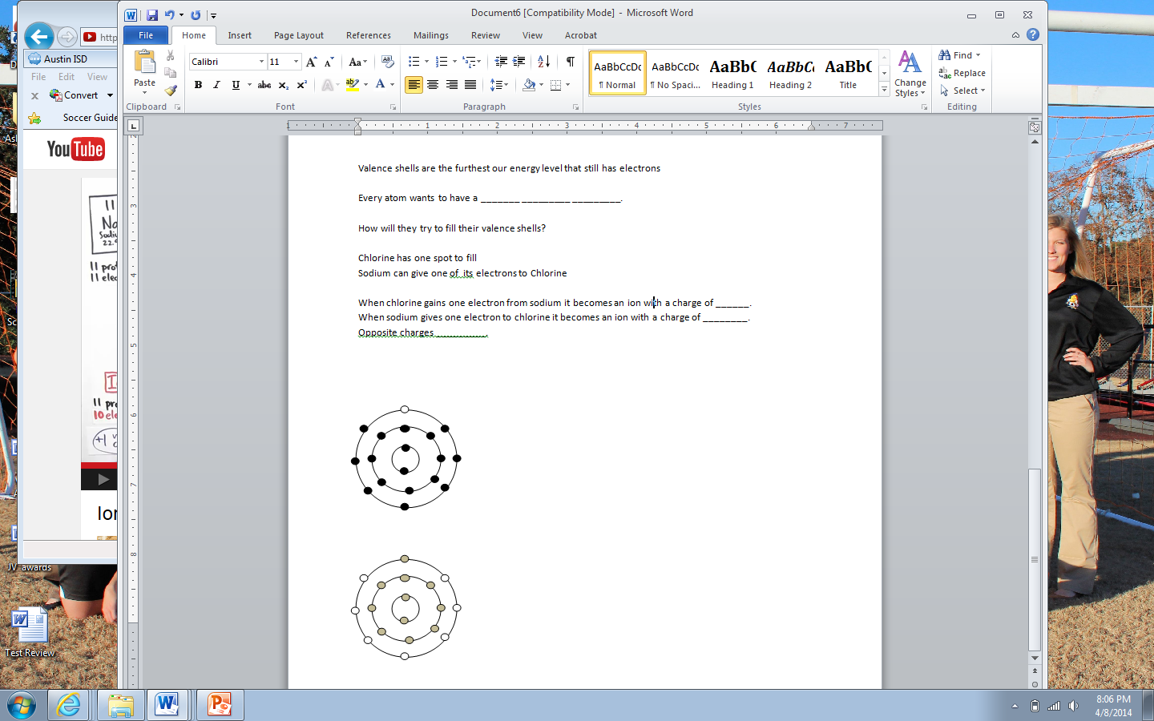
Every atom wants to have a ___________ _____________ _____________.
11p
17p

How will they try to fill their valence shells?
Chlorine has one spot to fill.
Sodium can give one of its electrons to chlorine.
Now they both have full outer shells of electrons.

When chlorine gains one electron from sodium it becomes an ion with a charge of ________.
When sodium gives one electron to chlorine it becomes an ion with a charge of ________.
Opposite charges _____________.

“How do I find the number of valence electrons?”
The number of valence electrons for an element is the same as the group number for that element on the Periodic Table.

