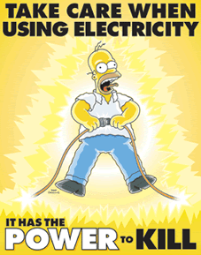
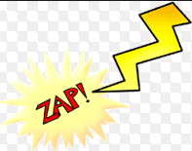
Ohm’s Law Notes: Electrical circuits
1) Ohm’s Law explains the relationship between _______________, _____________________, and _________________________.

2) Voltage Definition:
______________________________________________________________________________________________________________________________________________________________________

Voltage units: ______________________

How should you think about Voltage?

______________________________________________________________________________________________________________________________________________________________________

3) Current Definition:

______________________________________________________________________________________________________________________________________________________________________

Current Units: _____________________________

How should you think about Current?

______________________________________________________________________________________________________________________________________________________________________

4) Resistance Definition:
______________________________________________________________________________________________________________________________________________________________________

Resistance Units: ____________________________ Resistance Symbol:___________

How should you think about Resistance?
______________________________________________________________________________________________________________________________________________________________________

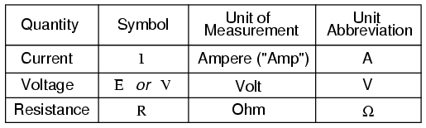

5) General Rules:
If Resistance does not change:
As _____________________________ increases, _____________________ increases.
As______________________________ decreases, ____________________ decreases.

6) If Voltage does not change:
As ____________________________ increases, ______________________ decreases.
As ____________________________ decreases, ______________________ increases.

7) Triangle Method for Ohm’s Law

V =

I =

R=

8) Example Problems:
1) A circuit has a battery that is supplying 12 Volts and resistance is 2 Ohms. What amount of current is traveling through the circuit?

G:

U:

E:

S:

S:

2) A Battery is supplying a voltage of 12 V. The current moving through the circuit is 4 Amps. What is the resistance of the circuit?

G:

U:

E:

S:

S:

9) Why do we need Resistors?

______________________________________________________________________________________________________________________________________________________________________

10) What are the 2 kinds of circuits?
_______________________________ and ___________________________.

11) In a _____________________ circuit there is ____________ pathway for _______________ to flow. Example:________________________________________

12) In a _____________________ circuit there is ____________ pathways for _______________ to flow. Example:________________________________________

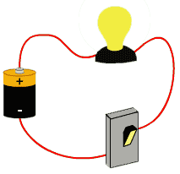
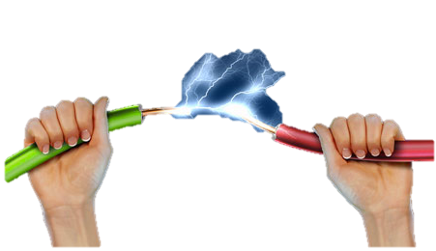

Label the Series circuit below.
Use the following: Battery, Wire, Switch, Light Bulb, Resistor.
Draw the current flow around the circuit using an arrow.

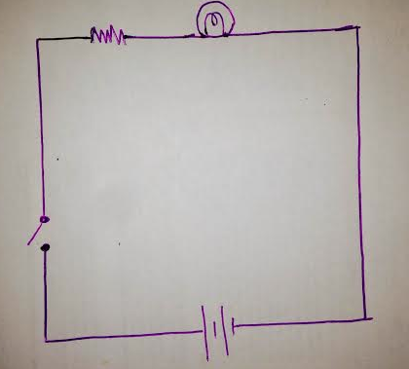
Label the parallel circuit below.
Use the following: Battery, Wire, Switch, Light Bulb, Resistor.
Draw the current flow around the circuit using an arrow.

