Vocabulary: Biology Unit: 12 Ecology part I Date: 5th 6 weeks
Picture | Word | Definition
 | Ecology | The study of the interactions of organisms with one another and their physical environment.
 | Biotic | The living (now or past) factors in an environment.  --animals, plants, insects, decomposers, etc.
 | Abiotic | The non-living factors in an environment.  -sunlight, temperature, water, climate, soil, etc.
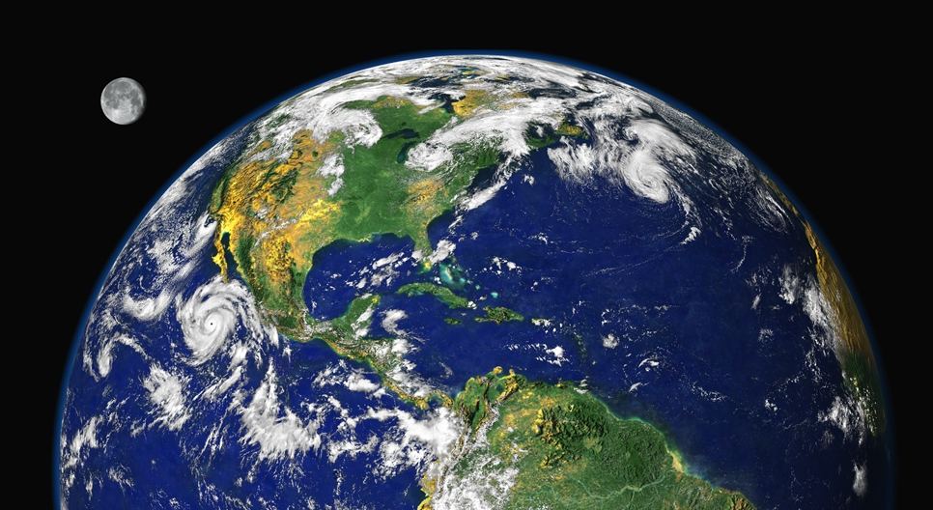 | Biosphere | All of the areas on Earth in which an organism can live.  -oceans, atmosphere, land, etc
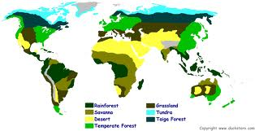 | Biome | An ecosystem that covers a large area and that has characteristic biotic and abiotic factors.  -Ex: Desert, tropical rainforest, deep ocean, tundra, grassland
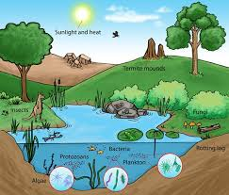 | Ecosystem | All of the communities (biotic factors) and all of the physical factors (abiotic) in a given area.  -Ex: The animals, plants, water, soil, and climate of the grasslands of central Oklahoma.
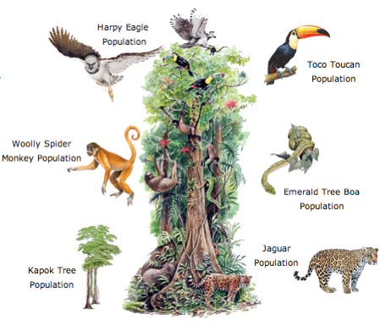 | Community | All of the different populations living in the same area at the same time.  --Only the biotic factors of an ecosystem/habitat.  --Ex: monkeys, birds, frogs, trees and vines of jungle.
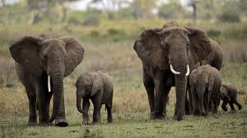 | Population | The number of individuals of the same species living in the same place at the same time.  -Ex: A herd of elephants, a troop of monkeys, the population of humans living in Austin right now.
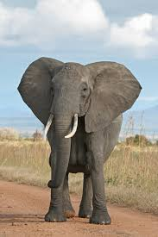 | Organism | A single living thing  -Ex. A zebra, an elephant, an insect, a palm tree, a bacteria, etc.

Picture | Word | Definition
 | Habitat | Where an organism lives.  -Ex: Monkeys live in Central American jungle, whales live in deep Pacific Ocean, zebras lives in grasslands of Africa.
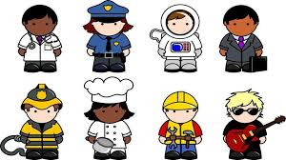 | Niche | An organism’s role or job in an ecosystem.  -Ex: a zebra’s job is to be a grazer (eat grass). A woodpecker’s job is to drill holes in the tops of dead trees to find and eat insects.
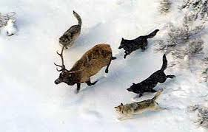 | Predation | A type of interaction between organisms in which one organism captures and feeds on another organism.  -Predator = hunter, prey = one eaten  --Ex: Wolf and deer, Hawk and mouse
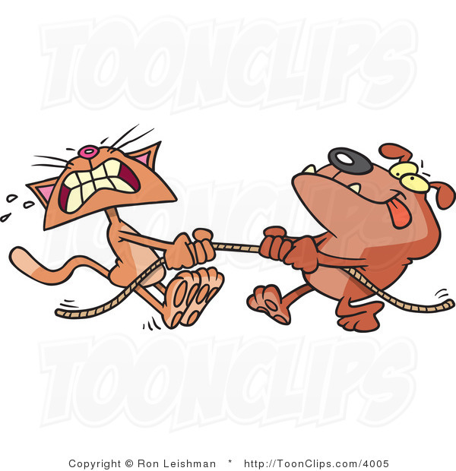 | Competition | A type of interaction between organisms (same or different species) in which both want the same thing (resource).  --Both want water, food, shelter, space, mates, etc.  -Harmful for everybody. Leads to evolution.
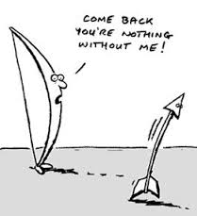 | Symbiosis | Any relationship in which two different organisms live closely together.  -mutualism  -commensalism  -parasitism
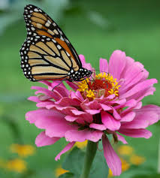 | Mutualism | A type of symbiotic relationship in which both organisms benefit from the relationship.  -Flowers and butterflies: flower gets pollinated and butterfly gets food.  -Lichen: fungus gets food from algae and algae gets a protected home.
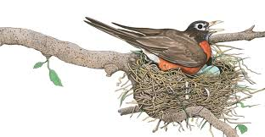 | Commensalism | A type of symbiotic relationship in which one organism is benefited while the other organism is neither helped or harmed.  Ex: birds and trees: bird builds nest, tree isn’t affected.
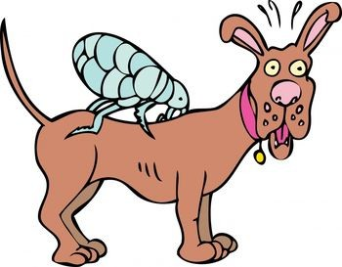 | Parasitism | A type of symbiotic relationship in which one organism (parasite) benefits while the other organism (host) is harmed.  Ex: Fleas (parasite) on dog (host). Flea feeds on dog’s blood, dog is losing blood, getting sick, etc.

