Vocabulary: Biology Unit 12: Ecology Part III Date: 5th 6 weeks
Picture | Word | Definition
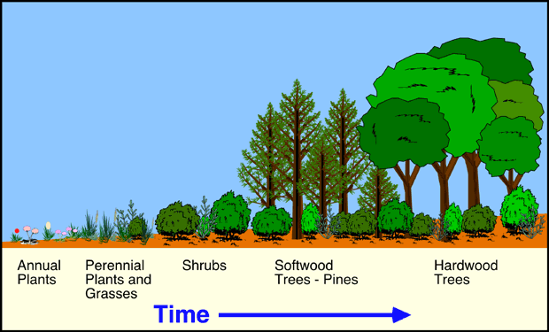 | Succession | Change in a community over time where one species replaces another species.  --lichens/mossesgrassessmall shrubslarger shrubs/small treesmature trees.  --Diversity increases as succession continues
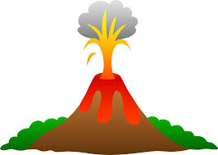 | Primary Succession | A type of succession that begins in a location where no soil exists.  --After volcanic lava flows, bare rock exposed as glaciers melt, volcanic island.  --Pioneer species provide soil over time  --Takes a long time.
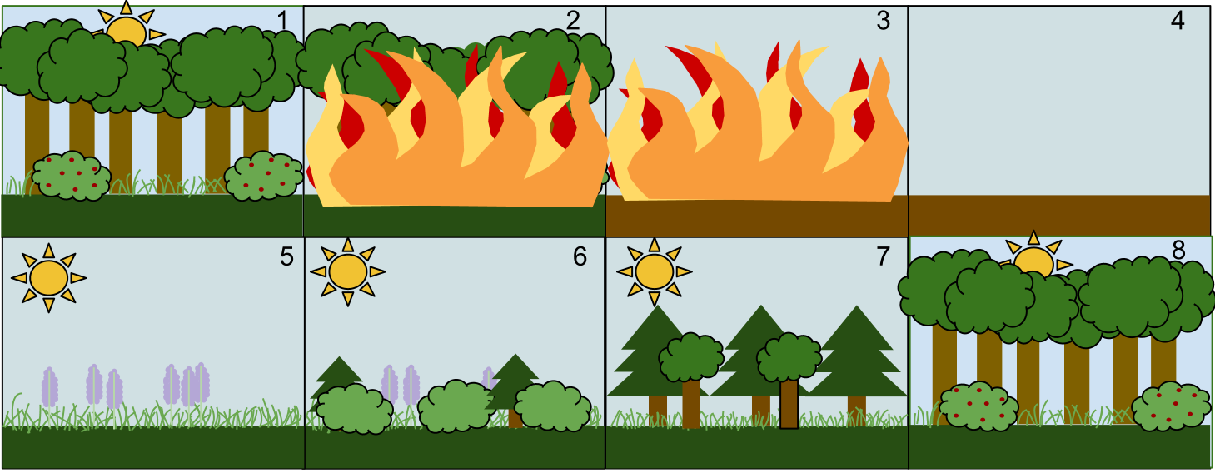 | Secondary Succession | A type of succession that begins in a location where soil/life has existed before.  --After a fire, flood, drought, hurricane, tornado, etc.  --Requires less time than primary succession
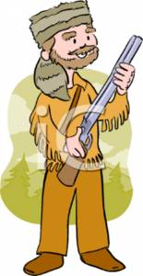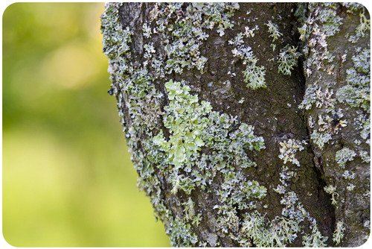 | Pioneer Species | The first species to colonize an area after a disturbance.  --prepares the area for future growth.  ----as they decompose, soil is built up.  --lichens and mosses, annual plants.
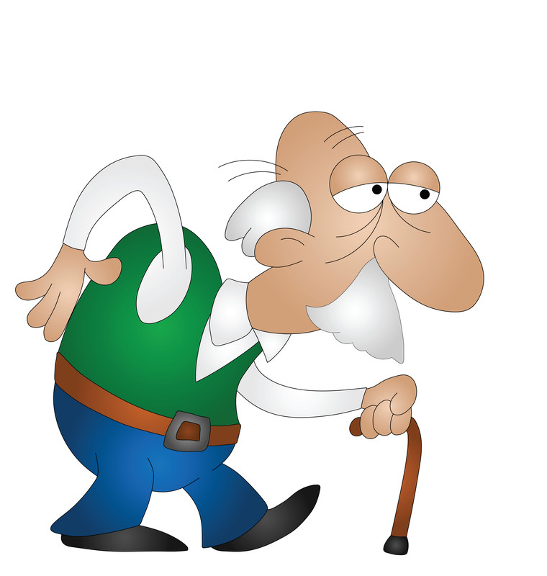 | Climax community | A stable, mature ecosystem.  ---The final stage in the succession of an ecosystem.  --Ex: Oak hickory forest, plants and fish found in a mature pond.
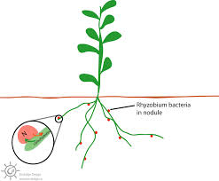 | Nitrogen Fixation | The process by which Nitrogen gas (N₂) is changed into a form that can be taken up and used by plants.  --Lightening, nitrogen fixing bacteria in plant roots, nitrogen fixing bacteria in soil.
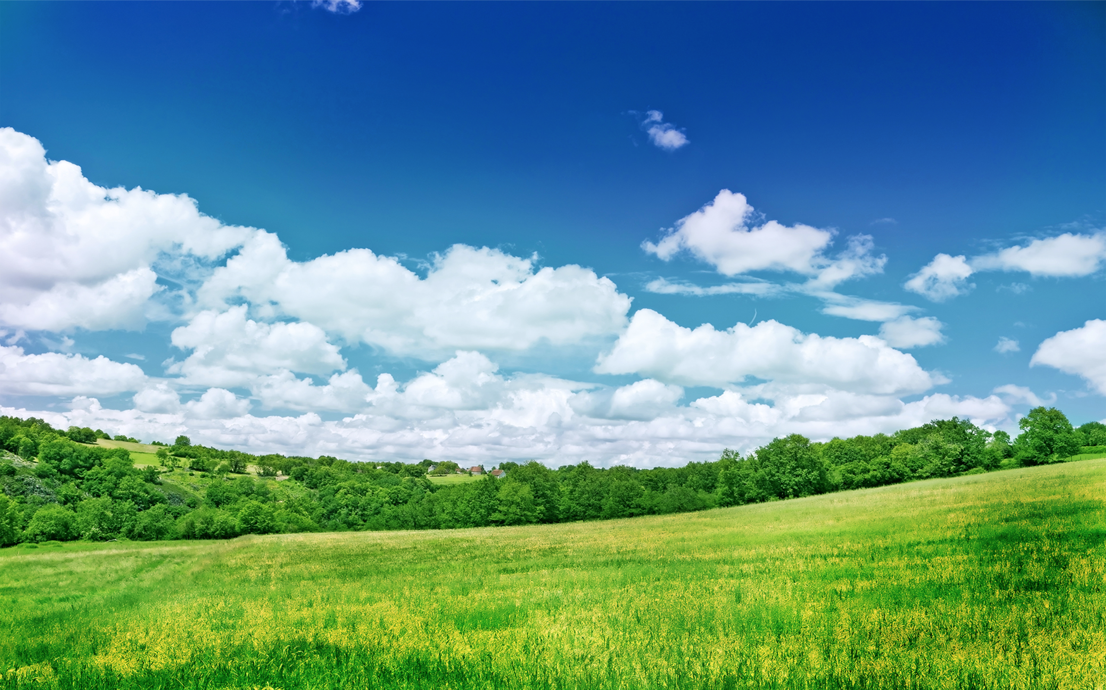 | Denitrification | The process by which Nitrogen is changed into nitrogen gas (N₂) and released from the soil back into the atmosphere.  ---Denitrifying bacteria and fungi in soil
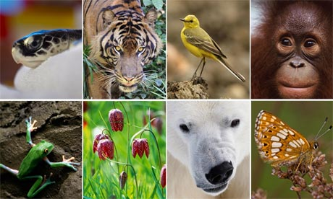 | Biodiversity | The many different forms of life found in an ecosystem.  --The more complex (more resources) an ecosystem, the more biodiversity there is.

Picture | Word | Definition
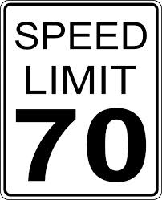 | Limiting factors | Any factor that limits the growth or development of an organism or population.  --food, water, shelter, space, amount of sunlight, predation, temperature, etc.
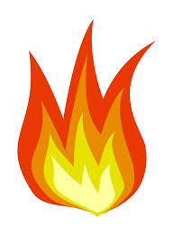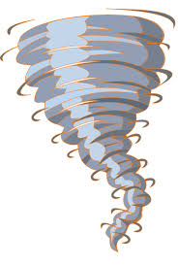 | Density independent factor | Limiting factors that are not affected by population size.  --Fires, storms/hurricanes, flooding, tornados, habitat destruction, drought.  --Large and small populations are equally affected.
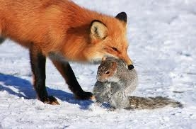  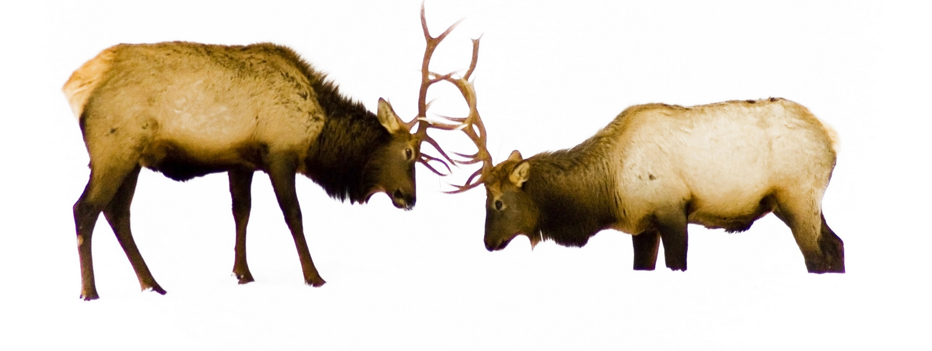 | Density dependent factor | Limiting factors in an ecosystem that are affected by population size.  --Competition, predation, parasitism, disease  --Larger populations are more affected than smaller populations.
 | Carrying capacity | The maximum population size that an ecosystem can support.  --Available resources (food, water, shelter ) determine the carrying capacity of a species.

