Vocabulary: Biology Unit: Date:
Picture | Word | Definition
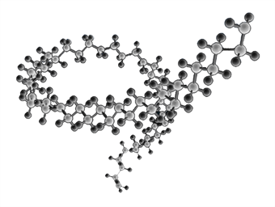 | Polymer | A large molecule made from smaller molecules –made from monomers
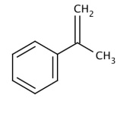 | Monomer | A single molecule  --a building block for polymers
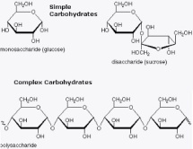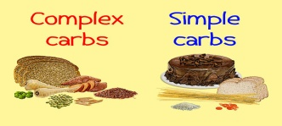 | Carbohydrate | A macromolecule made from carbon, hydrogen, and oxygen (CH₂O)  -monomer = monosaccharide  -ex: sugar (monosaccharides) and starch, cellulose, glycogen (polysaccharides)  -function: quick energy and structure in plants
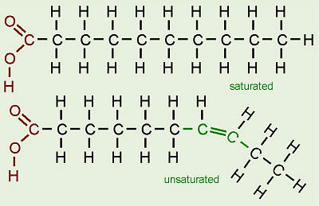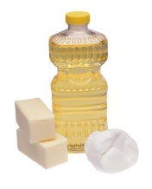 | Lipid | A macromolecule made from oxygen and chains of carbon and hydrogen.  -monomer: glycerol and fatty acids  -ex: fats, oils, steroids, waxes, phospholipids  -Function: long term energy storage, insulation, cell membranes
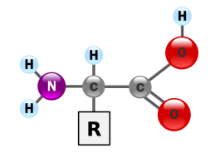  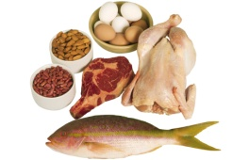 | Protein | A macromolecule made from carbon, hydrogen, nitrogen, and oxygen.  -monomer: amino acids (20 different)  -ex: keratin, enzymes, muscles, eggs  -function: order of amino acidsshapejob  ----transport, regulation, contractile, enzymes, support.  --proteins control and build much of life activities.
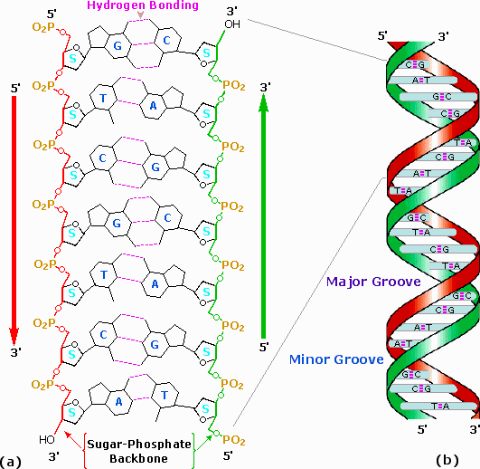 | Nucleic Acid | A macromolecule made from pentose sugar, phosphate group and nitrogenous base.  -monomer: nucleotide  -ex: DNA and RNA  -Function: genetic information, build proteins

Picture | Word | Definition
 | Enzyme | Biological catalyst. A helper protein molecule that speeds up chemical reactions in living things. Synthesis enzymes build things, digestive enzymes break down things. “The Key.”
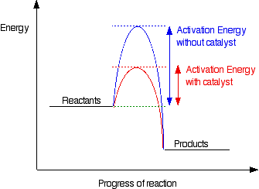 | Catalyst | Anything that speeds up a chemical reaction by lowering the activation energy (the energy needed to get a reaction started). “Your hand” in putting the key in the lock.
 | Substrate | The molecule that is acted upon (broken down or put together) by the enzyme. It requires a specific enzyme. “The Lock.”
 | Product | The molecule or molecules produced after the enzyme has acted upon the substrate. “The locked or unlocked door.”
 | Active Site | The area of an enzyme where the substrate fits. This is the area that will change shape to either build or break down molecules. “The Key hole.”

