- What are the components of a DNA nucleotide? Draw and label one.

- What are the components of an RNA nucleotide? Draw and label one.

- What are the nitrogenous bases found in DNA? RNA?

- How many strands does DNA have? RNA?

- What is made during DNA replication? Where does it occur?

- What are the three types of RNA? What are their functions?

- What are the two processes involved in protein synthesis? What is produced during each process?

- Where do these two processes occur?

- What enzyme is needed in order to make an mRNA molecule from the DNA template?

- Using the above diagram, name each numbered item/place that is involved in the process of protein synthesis in order from start to the final product.

- What is a codon? What does it code for?

- What is an anticodon?

- Describe the steps of protein synthesis from start to final product. What happens? (look at the previous diagram to help with details)

- When looking at an mRNA molecule, such as the one below, how can you determine how many amino acids will be made? What is structure A? Structure B? Structures C, D, and E?
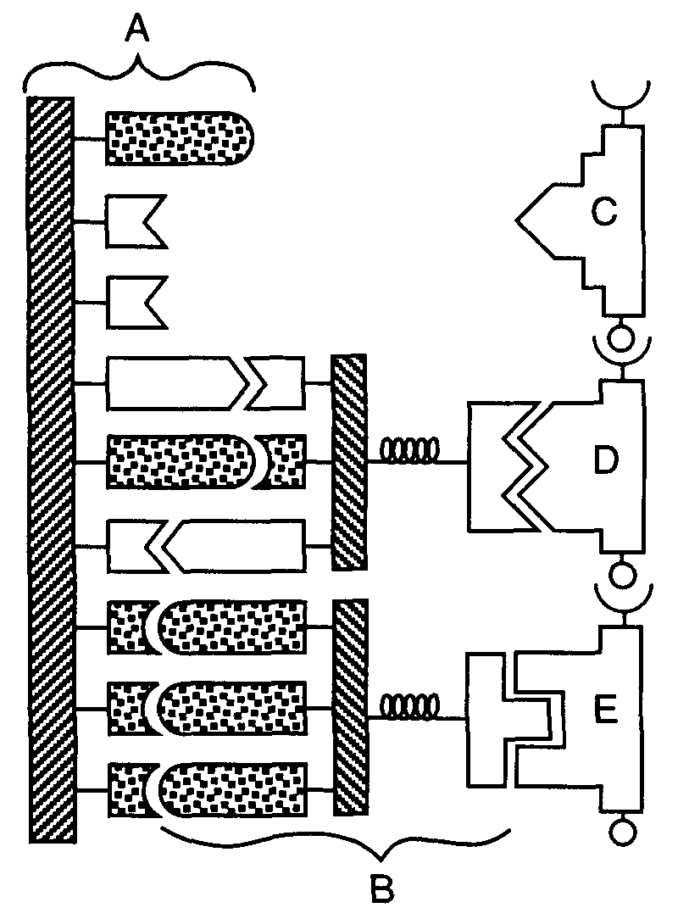

- If a DNA sequence reads ATTCGCTATGGC: What will be the complementary strand for?
  - mRNA?
  - tRNA?
  - Amino acids?

- What mRNA sequence (codons) would code for serine-histidine-alanine-stop? What DNA sequence would be the template for this mRNA sequence? (if there is more than one possible mRNA codon, just choose one)

- Which cell organelle is directly involved in the translation part of protein synthesis?

- What is the relationship between DNA and the traits of an organism?

- What is the relationship between a cell, DNA, and a protein?

- What is the relationship between the nucleus of a cell, a gene, and a chromosome?

- What determines the job of a protein?

- What determines the shape of a protein?

- What determines the order of amino acids in a polypeptide chain?

- What happens to a protein if DNA is changed?

- What type of molecule is an enzyme? What determines their job? Who originally determines their job?

- What is a mutation? How can it affect a protein?

- What are the three main types of mutations and illustrate this type of mutation using the DNA base sequence ATTCCGAGA?

- What causes a mutation to occur in the DNA of an organism?

- When is a mutation passed from parent to offspring?

- Use your genetic code (codon chart) to determine the effects of a mutation on a protein.

  - Normal DNA: TACCACGGGATA
    - mRNA:
    - amino acids:

  - Altered DNA: TACCACCGGATA
    - mRNA:
    - amino acids:
    - What changed?

  - Altered DNA: TACCAACGGGATA
    - mRNA:
    - amino acids:
    - What changed?

