Vocabulary: Biology Unit: 4: photosynthesis and cellular respiration Date:
Picture | Word | Definition
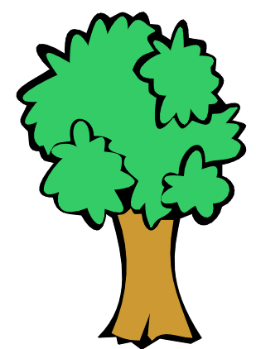 | Autotroph | *An organism that can make its own food  *Ex: plants, algae, photosynthetic organism
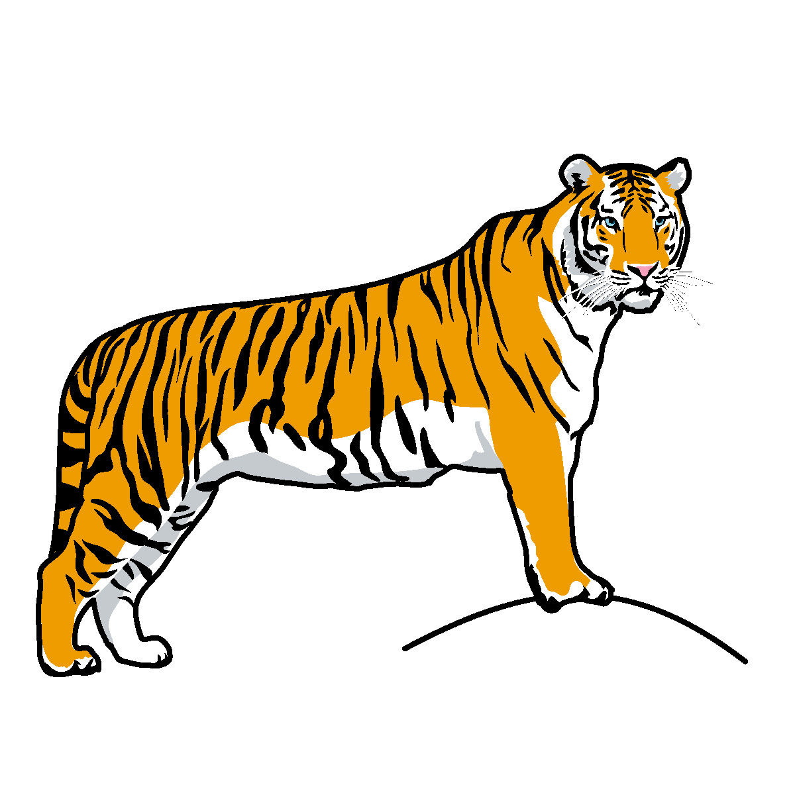 | Heterotroph | *An organism that cannot make its own food, it must consume other organisms.  *Ex: animals, fungi, some protists
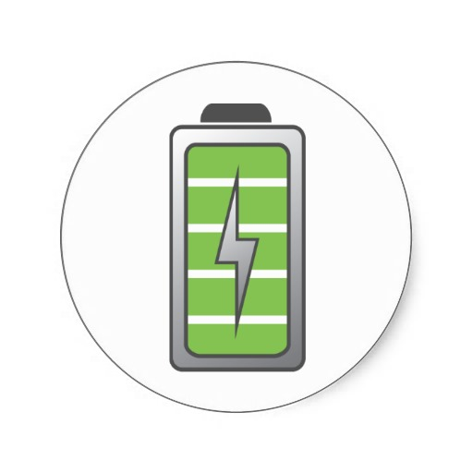 | ATP | *Adenosine triphosphate  *Cellular energy  *Made by adding a phosphate onto ADP.  ATP=fully charged battery
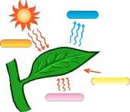 | Photosynthesis | *The process of converting solar energy into chemical energy. Using sunlight to make sugar.  *Plants, algae, photosynthetic bacteria  6CO₂ + 6H₂O + sunlight C₆H₁₂O₆ + 6 O₂
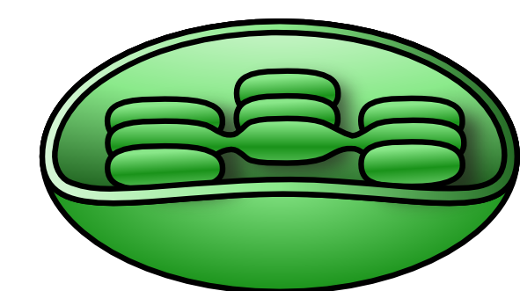 | Chloroplast | *The organelle where photosynthesis takes place.  *Found in plant and other photosynthetic eukaryotes (protists)
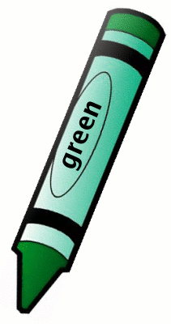 | Chlorophyll | *The pigment found inside a chloroplast that gives plants their green color  *Absorbs the solar energy and converts it into chemical energy.
 | Cellular respiration | *The process by which food is broken down to release the energy held within the bonds for cellular processes.  *Converts chemical energy into chemical energy.  *Can occur with or without oxygen
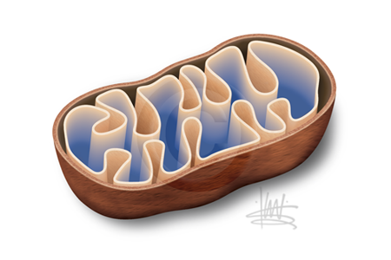 | Mitochondria | *The organelle where aerobic respiration occurs.  *Found in all eukaryotic cells (plants, animals, fungi and protists).
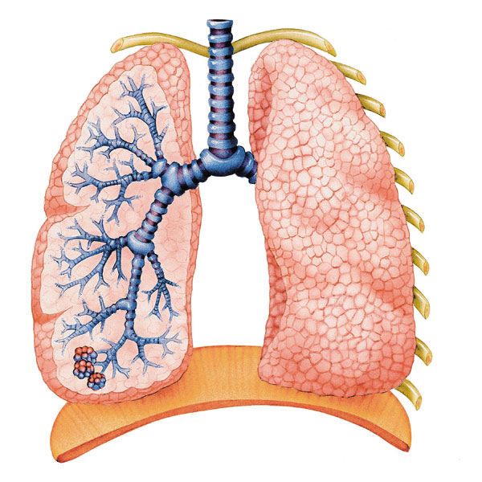 | Aerobic respiration | *Cellular respiration in the presence of oxygen.  *Occurs within the mitochondria.
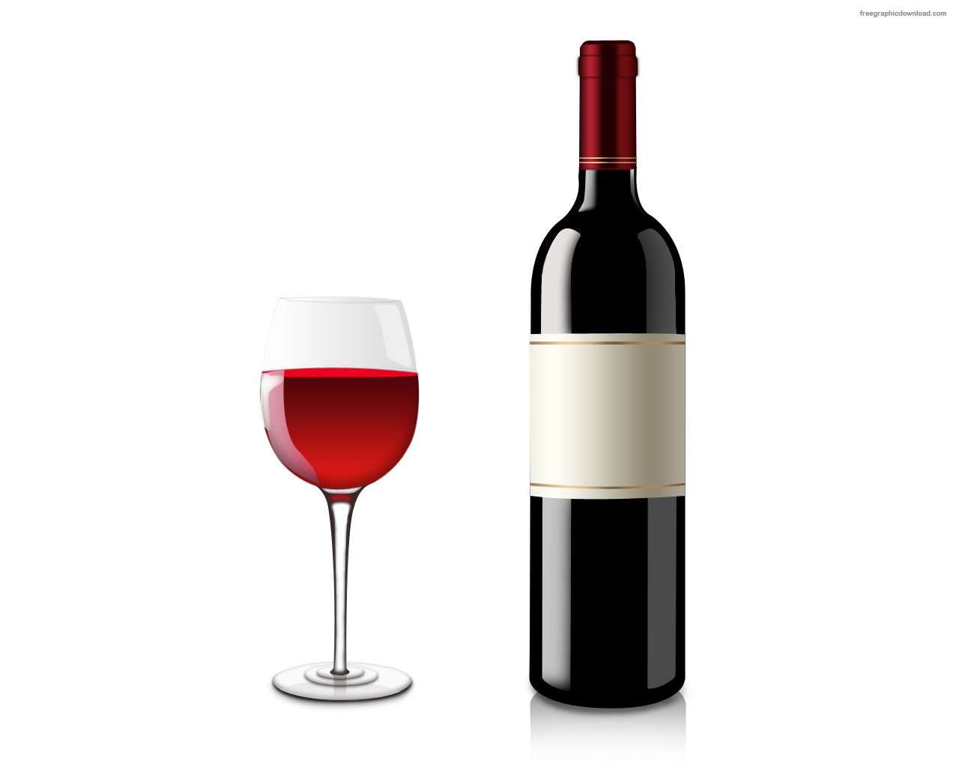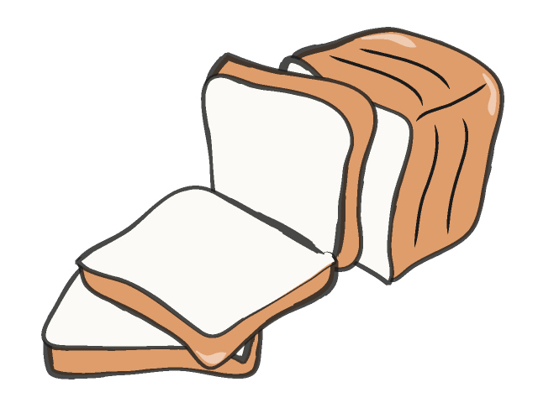 | Fermentation | *Anaerobic respiration  *Cellular respiration when oxygen isn’t available.  *Lactic acid fermentation produces sore muscles, yogurt, cheese  *alcoholic fermentation produces alcohol and bread.
A + B | Reactants | *What goes into a chemical reaction  *The ingredients
AB | Products | *What comes out of a chemical reaction  *What is produced  *The final product

